Scenario #7: View Recommendations

# Description

This test scenario covers a user attempting to view recommended games recommended to them

The test scenario covers a user viewing their recommendations of games based on their user settings

* View Recommendation option available upon authentication
* User settings needs to updated with preference over Genre and characteristics
* View content on view recommendations and move to next recommendation

# Test Scripts

The following scripts will cover this scenario:

* 7.1. View Recommendation Signed In
* 7.2. View next recommendation
* 7.3. Rate Recommended Games

# Use Case

When User

Wants to View Recommendations, upon signing in and updating user settings

So that the User is granted access to recommended games based on updated user settings of preferred Genres and Characteristics

# Test Components/Requirements

This test scenario covers the following high-level test requirements (see scripts below for specific requirements covered by each test script):

* Authentication
* Recommended Games to authenticated user
* Persistence

# User Groups

* Average user

# Script 1: View Recommendation Signed In

## Description

* An unauthenticated user will visit a page of the site where the navigation bar is offered (currently all pages)
* Signs in and attempt to view Recommendation
* Observe the result - The user should then have access to recommended games if the user settings are updated

## Setup

* The testing user should ensure they are logged in
* The testing user should ensure that they have updated their user settings upon signing in

|  |  |  |  |  |
| --- | --- | --- | --- | --- |
| **Step #** | **Test Step** | **Expected Test Results** | **P** | **F** |
| **1.** | Visit the site | Site loads with no errors – there will be no option to view recommendations |  |  |
| **2.** | Click “Sign up” or “Sign in” in the top right | A modal window appears asking for registration details or log in details |  |  |
| **3.** | Once logged in Click “Settings” in the top right from the username drop down | A modal window appears providing Username, user’s email address and the ability to sect genres and characteristics via tick boxes on the left hand side of listed genres and characteristics |  |  |
| **4.** | Select “Genres” and “Characteristics “in the modal window via the ticking the box for selection. Click Save preferences to update Settings | The page refreshes and the modal window displays “Your Preferences have been saved” |  |  |

|  |  |  |  |  |
| --- | --- | --- | --- | --- |
| **5.** | Click on “View Recommendations” | The page refreshes and recommended game is presented to the user |  |  |

|  |  |
| --- | --- |
| **Field Name** | **Data** |
| Sign In / Sign Up | ssjj, Password |
| Genres Selected | Action , Adventure |
| Characteristics | Graphics |
| Recommended Game | Mini Motor Racing Evo |

|  |  |  |  |
| --- | --- | --- | --- |
| Date/Time | Tester | Test Phase | Status |
| 03/09/17 20:15 | Shailesh Jha | Alpha | Passed |

**Refer to the screenshots below:**

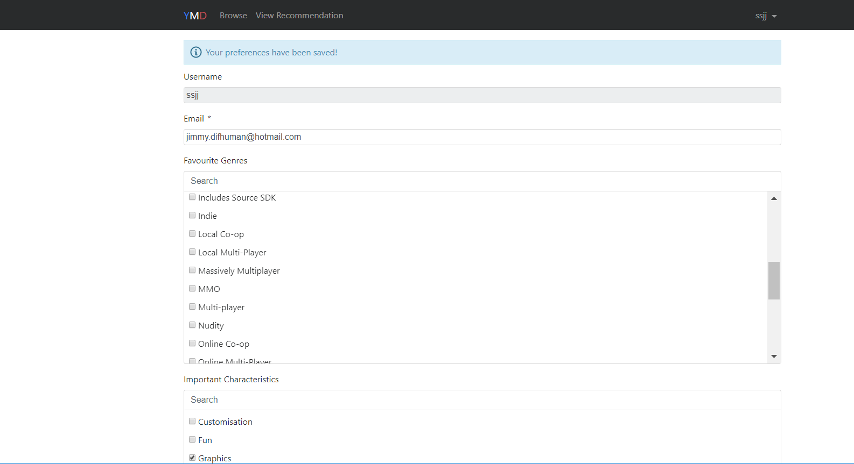

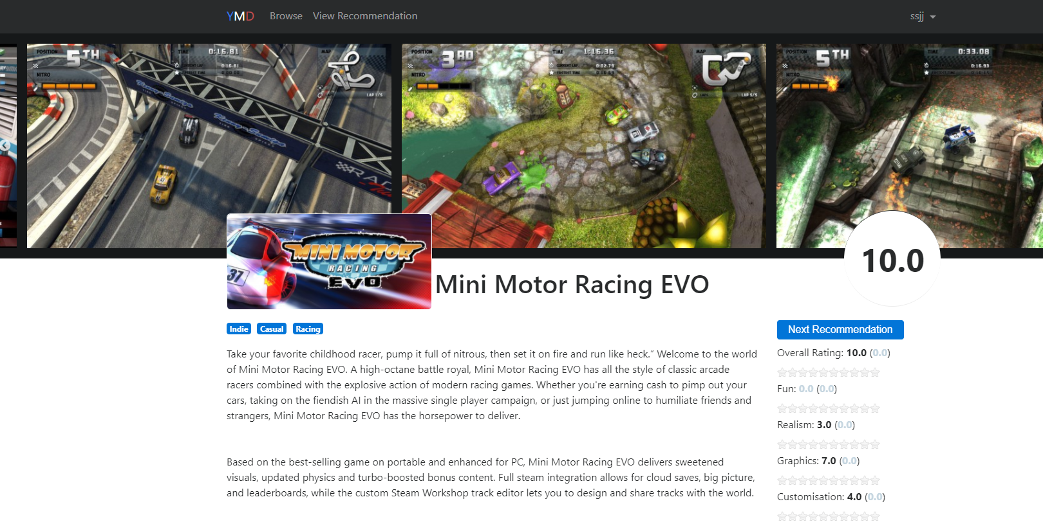

# Script 2: View Next Recommendation

## Description

* An authenticated user will visit the tab View Recommendation
* Attempt to View Next Recommendation upon a recommended game is presented to the user
* Observe the result - The user should then have next recommended game presented to them and subsequently next recommended game every time they click on next recommendation

## Setup

* The testing user should ensure they are logged in
* The testing user should ensure that they have updated genre characteristic via the update of User Settings
* The user should already be on the screen where they already have a recommended game presented to them upon clicking view recommendation as demonstrated in script 1

|  |  |  |  |  |
| --- | --- | --- | --- | --- |
| **Step #** | **Test Step** | **Expected Test Results** | **P** | **F** |
| **1.** | Perform all steps of Script 1 if not already performed | Site loads with no errors and a recommended game is presented to the user |  |  |
| **2.** | Click “Next Recommendation” on the right hand side of the game just below the games rating | The page refreshes and presents user with the next recommended game |  |  |
| **3.** | Click “Next Recommendation” again on the current page | The page refreshes and presents user with the next recommended game and continues to do so upon clicking next recommendation |  |  |

|  |  |
| --- | --- |
| **Field Name** | **Data** |
| Sign In | ssjj, Password |
| Genres Selected | Action , Adventure |
| Characteristics | Graphics |
| Recommended Game | Mini Motor Racing Evo |
| Next Recommended Game | X Rebirth , Day of Defeat |

|  |  |  |  |
| --- | --- | --- | --- |
| Date/Time | Tester | Test Phase | Status |
| 03/09/17 20:45 | Shailesh Jha | Alpha | Passed |

# 

**Refer to the screenshots below:**

# 

# 

# Script 3: Rate Recommended Games

## Description

* An authenticated user will visit a page of the site where the user is presented with a recommended game and the ability to view next recommendation
* Attempt to rate the game
* Observe the result - The user should then be able to rate the game and view the updated rating on the refreshed page

## Setup

* The testing user should ensure they are logged in
* The testing user should click on View Recommendation upon signing in and updating user settings

|  |  |  |  |  |
| --- | --- | --- | --- | --- |
| **Step #** | **Test Step** | **Expected Test Results** | **P** | **F** |
| **1.** | Perform the steps of script 1 and 2 | Site loads with no errors and the user is presented with a recommended game and every time they hit next recommendation they are presented with a new recommended game on the refreshed page |  |  |
| **2.** | Click on the “***”number of stars located just below the overall rating of the game on the right hand side, you would like to rate the game with | The selected amount of stars “****” turns yellow |  |  |
| **3.** | Click on “Rate” | The page refreshes updating the overall rating and the stars can be seen in yellow for the rating the user has provided the game with |  |  |

|  |  |
| --- | --- |
| **Field Name** | **Data** |
| Sign In | ssjj, Password |
| Genres Selected | Action , Adventure |
| Characteristics | Graphics |
| Recommended Game | Mini Motor Racing Evo |
| Next Recommended Game | X Rebirth , Day of Defeat |
| Rated Game | Bloodline champions : initial rating 3.0, updated rating 6 |

|  |  |  |  |
| --- | --- | --- | --- |
| Date/Time | Tester | Test Phase | Status |
| 23/08/17 21:15 | Shailesh Jha | Alpha | Passed |

**Refer to the screenshots below:**

# 